**Nama : Duvan Sanjaya**

**Kode Peserta : FSDO002ONL020**

**Tugas 1**

SOAL A

#a buat database

**create** **database** staff

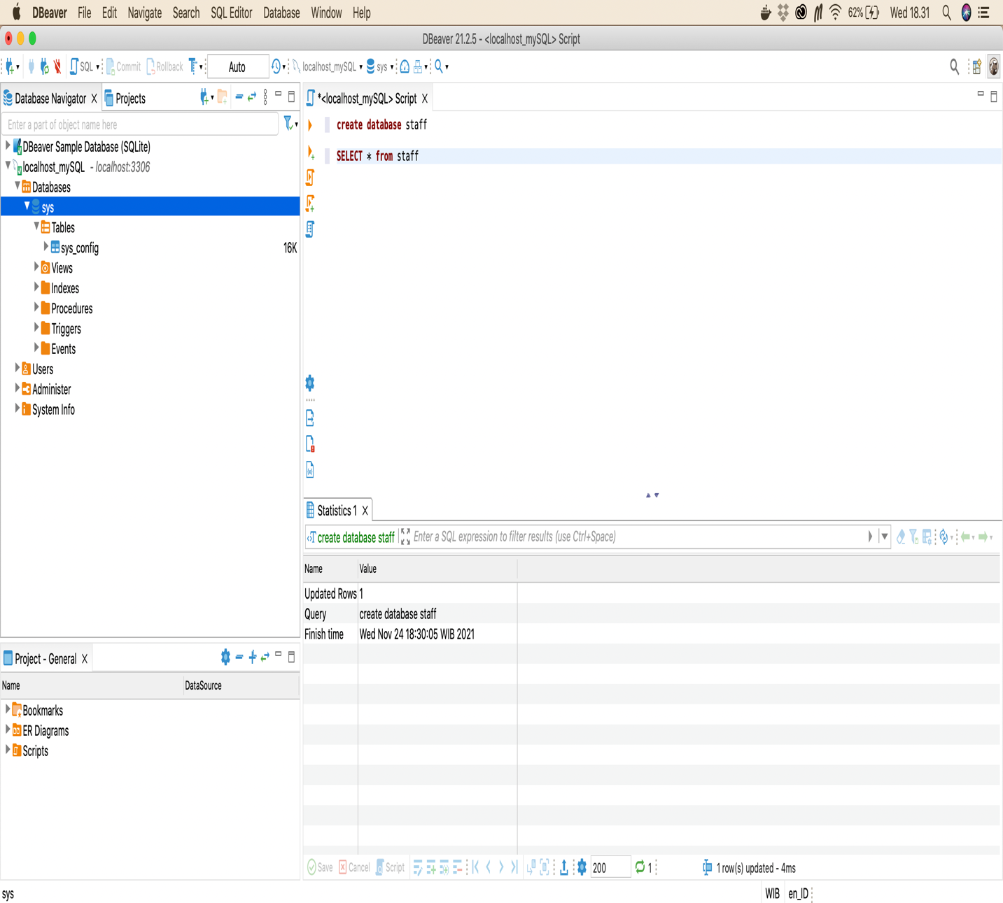

SOAL B

#b buat table data_staff

**CREATE** **TABLE** data_staff(

nik **INT** **NOT** **NULL**,

nama **VARCHAR**(50) **NOT** **NULL**,

alamat **VARCHAR**(200) **NOT** **NULL**,

handphone **VARCHAR**(15) **NOT** **NULL**

)

**select** * **from** data_staff

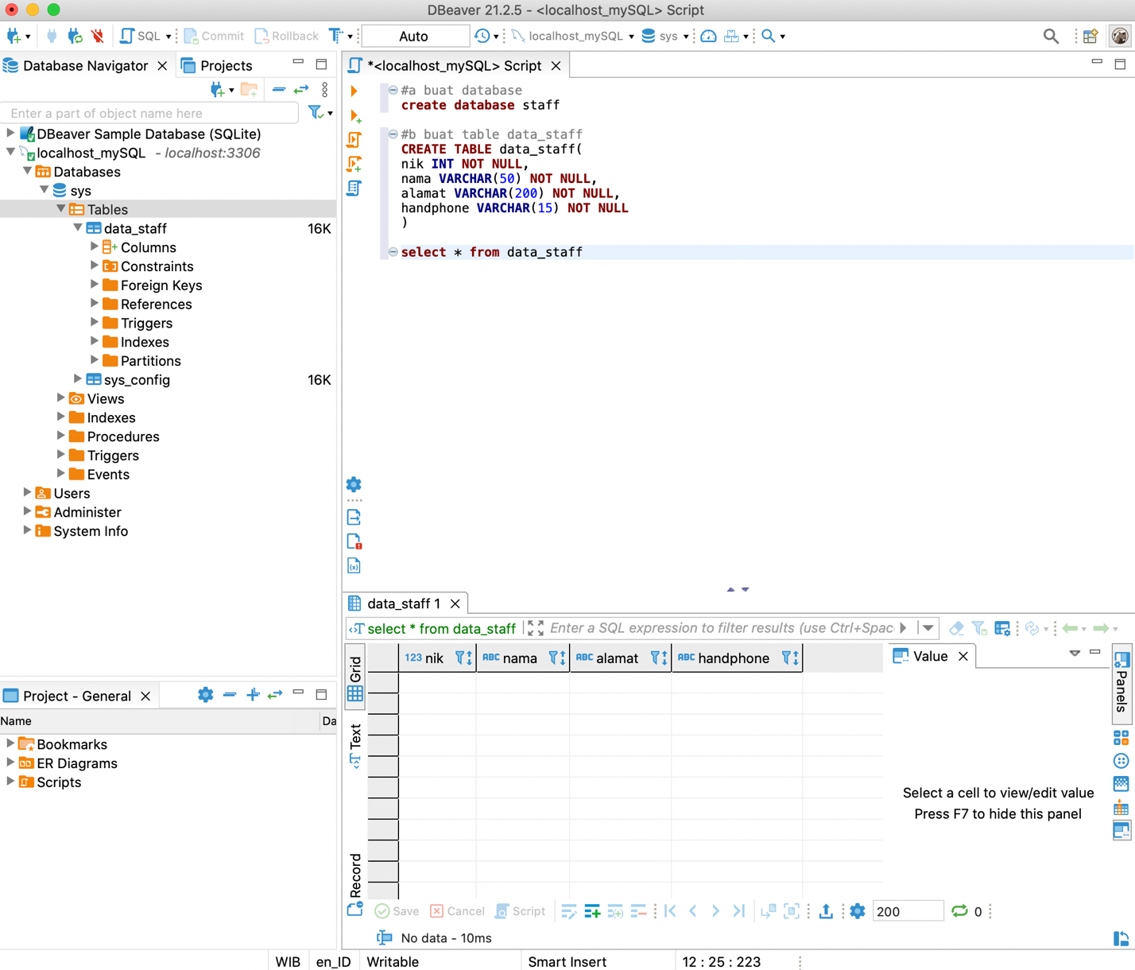

SOAL C

#c masukkan data kedalam table data_staff

**insert** **into** data_staff(nik,nama,alamat,handphone)

**values**('101','Albert','Pekanbaru','081268503339')

**select** * **from** data_staff

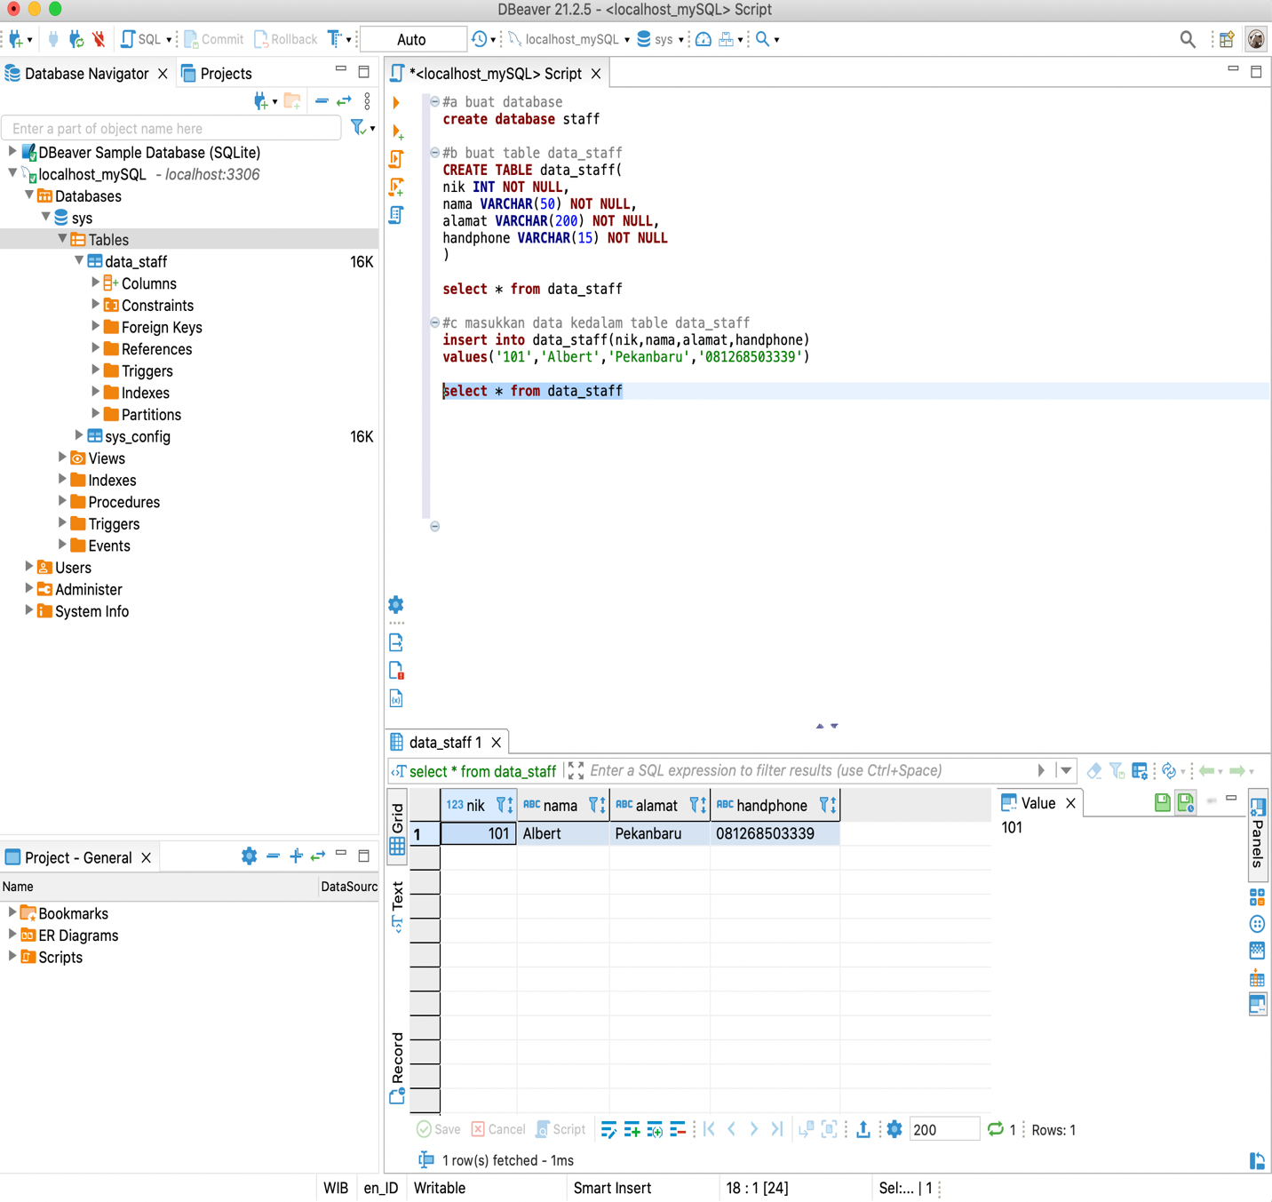

SOAL D

#d masukkan lebih dari 1 data kedalam table

**insert** **into** data_staff(nik,nama,alamat,handphone)

**values**('102','Cangry','Medan','081268503340')

**insert** **into** data_staff(nik,nama,alamat,handphone)

**values**('103','Dony','Semarang','081268503341')

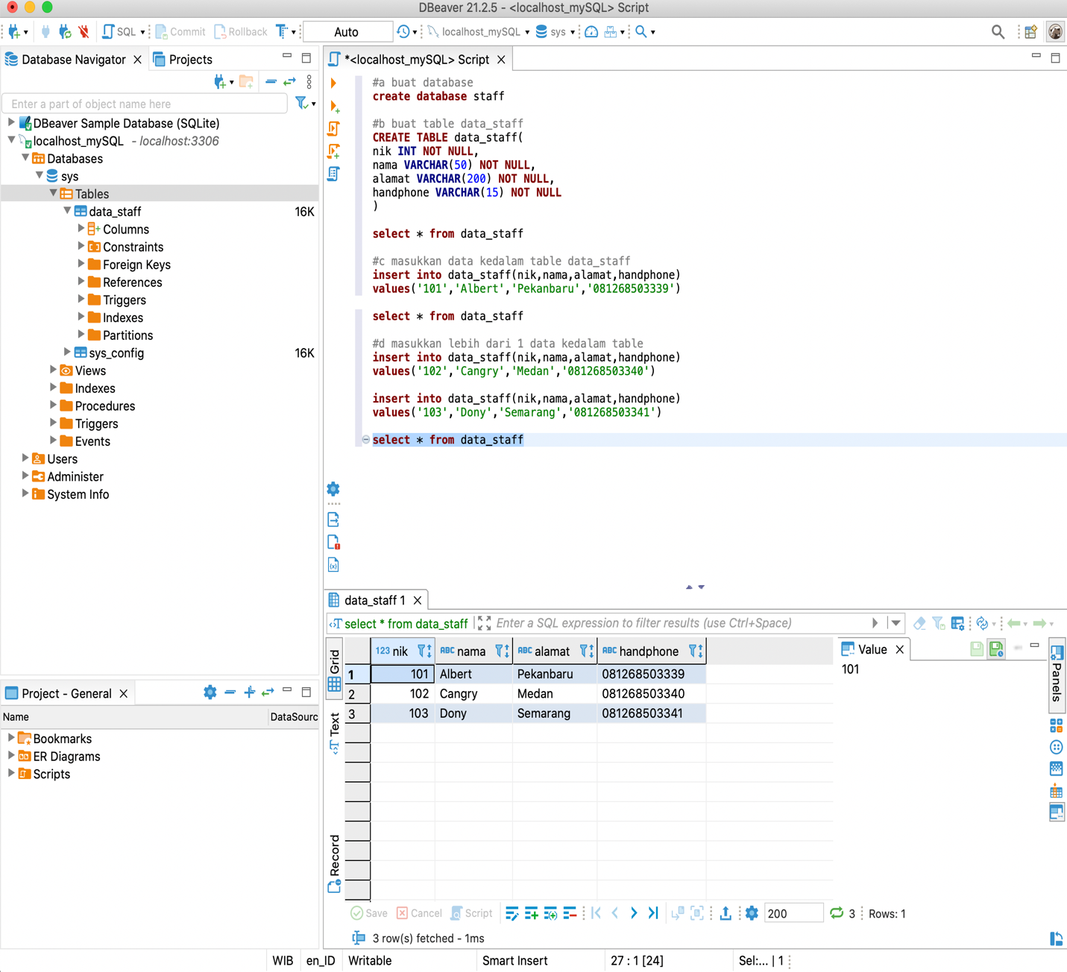**select** * **from** data_staff

SOAL E

#e tambahkan kolom baru pada table data_staff ->joindate, masukkan 1 data ke table data_staff

**alter** **table** data_staff **add** joindate **date** **null**

**insert** **into** data_staff(nik,nama,alamat,handphone,joindate)

**values**('104','Lampard','Jakarta','081268503342','2021-11-24')

**select** * **from** data_staff

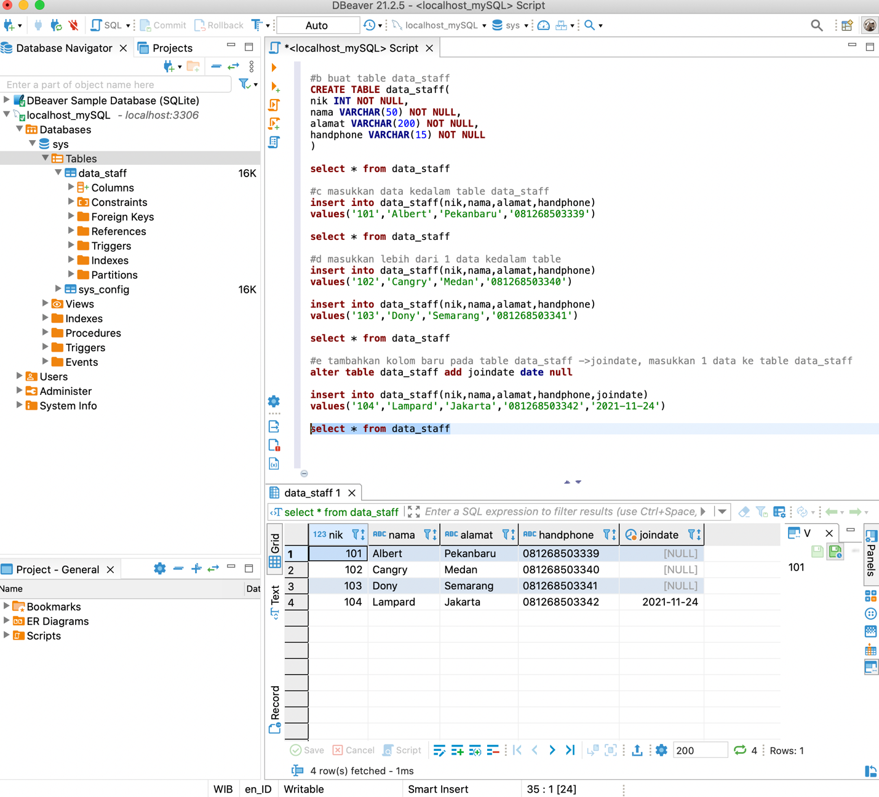

SOAL F

#f tampilkan 2 data sql

**select** * **from** data_staff **limit** 2

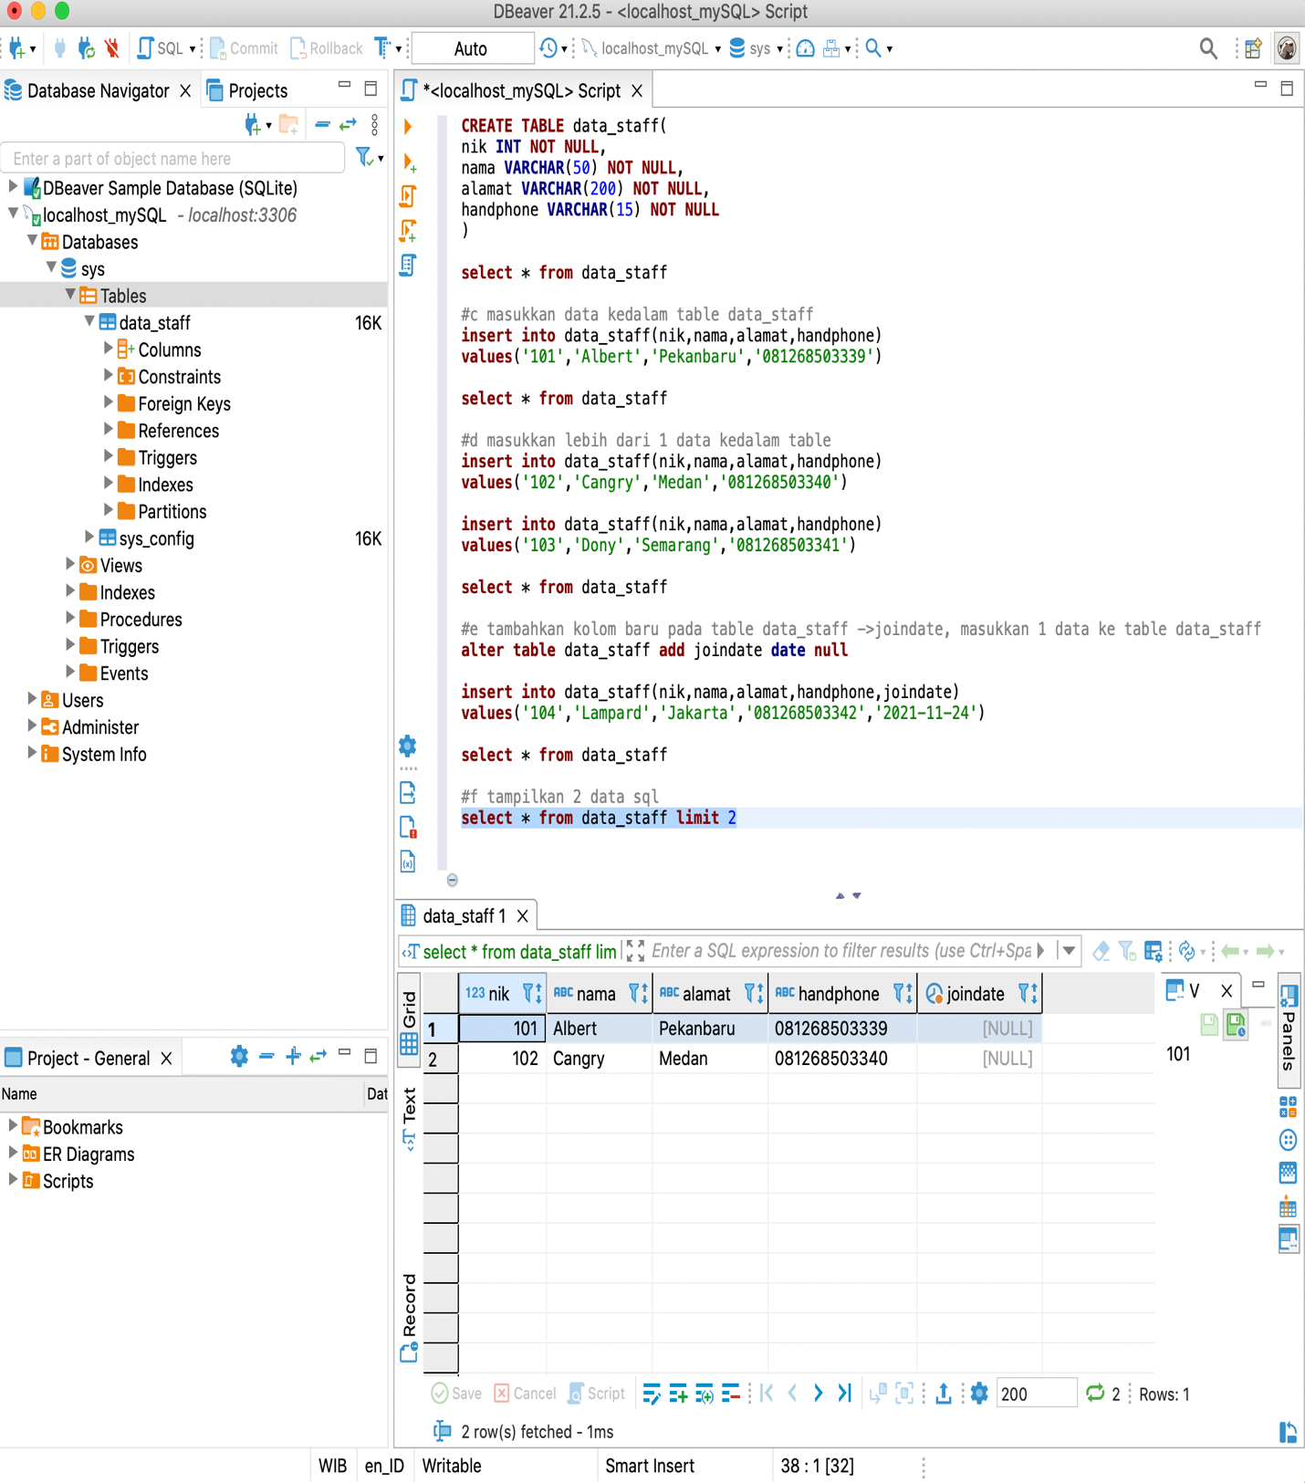

SOAL G

#g tampilkan 3 data sql

**select** * **from** data_staff **limit** 3

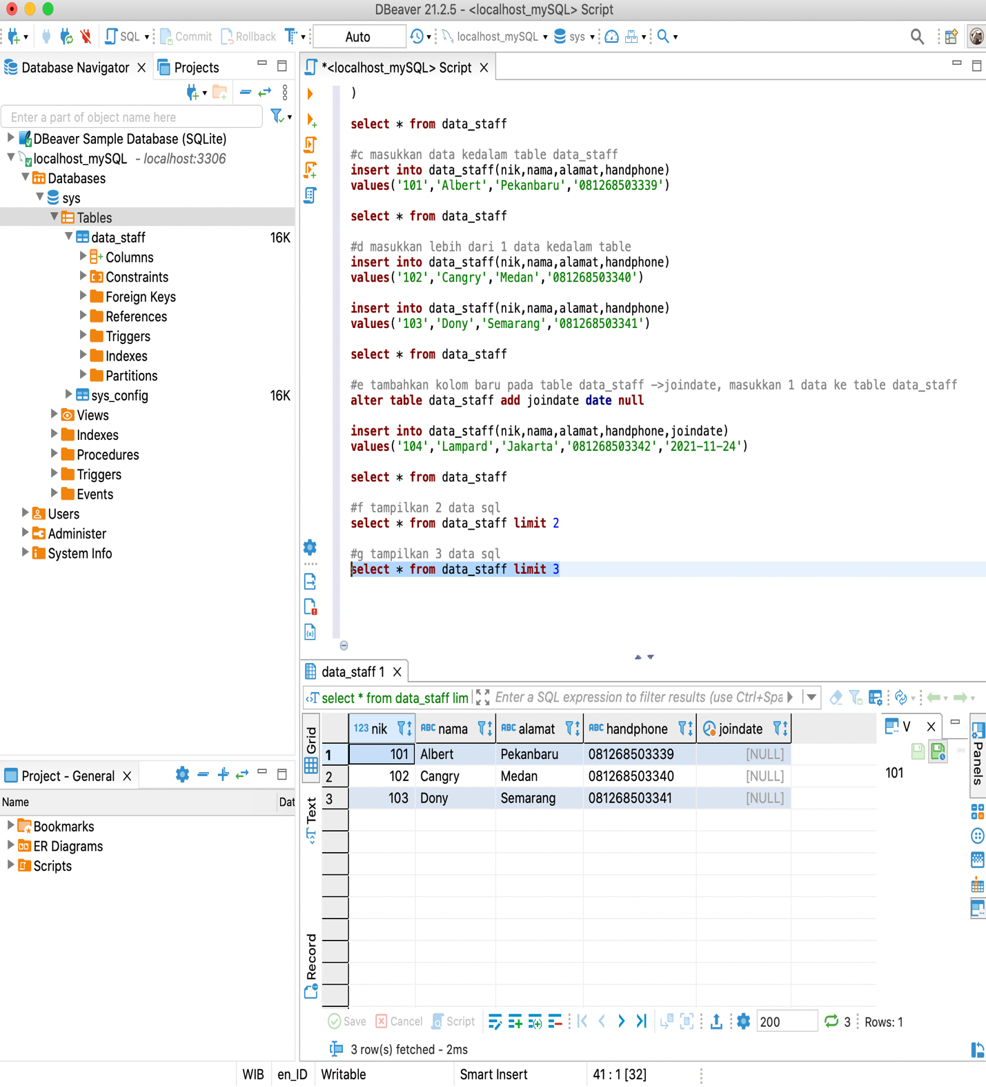

SOAL H

#h buat table baru staffoutsource dengan isi yang sama seperti data_staff

**create** **table** staffoutsource(

nik **int** **not** **null**,

nama **varchar**(50) **not** **null**,

alamat **varchar**(200) **not** **null**,

handphone **varchar**(15) **not** **null**,

joindate **date** **not** **null**

)

**select** * **from** staffoutsource

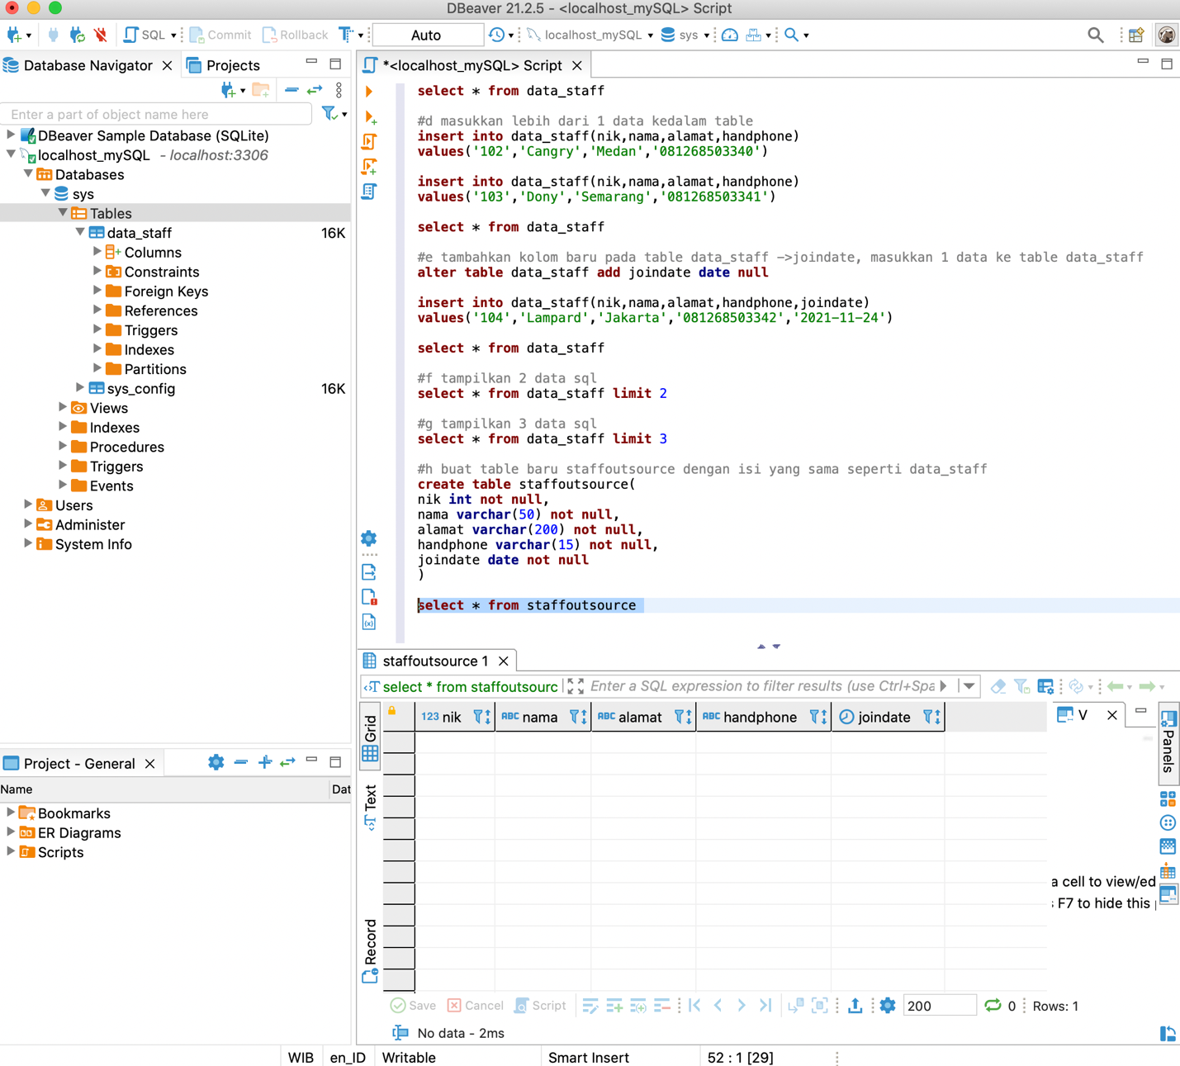

SOAL I

#i masukkan 10 data baru ke table staffoutsource

**insert** **into** staffoutsource(nik,nama,alamat,handphone,joindate)

**values**

('105','Ivysaur','Bandung','081212349876','2021-11-21'),

('106','Venusaur','Surabaya','081212346543','2021-11-22'),

('107','Mega Venusaur','Makasar','081212349933','2021-11-23'),

('108','Charmander','Medan','081212349988','2021-11-24'),

('109','Charmeleon','Pekanbaru','081212346767','2021-11-25'),

('110','Charizard','Pontianak','081212344567','2021-11-26'),

('111','Mega Charizard','Gorontalo','081212348877','2021-11-27'),

('112','Squirtle','Jogja','081212342233','2021-11-28'),

('113','Wartortle','Solo','081212343434','2021-11-29'),

('114','Blastoise','Padang','081212348787','2021-11-30')

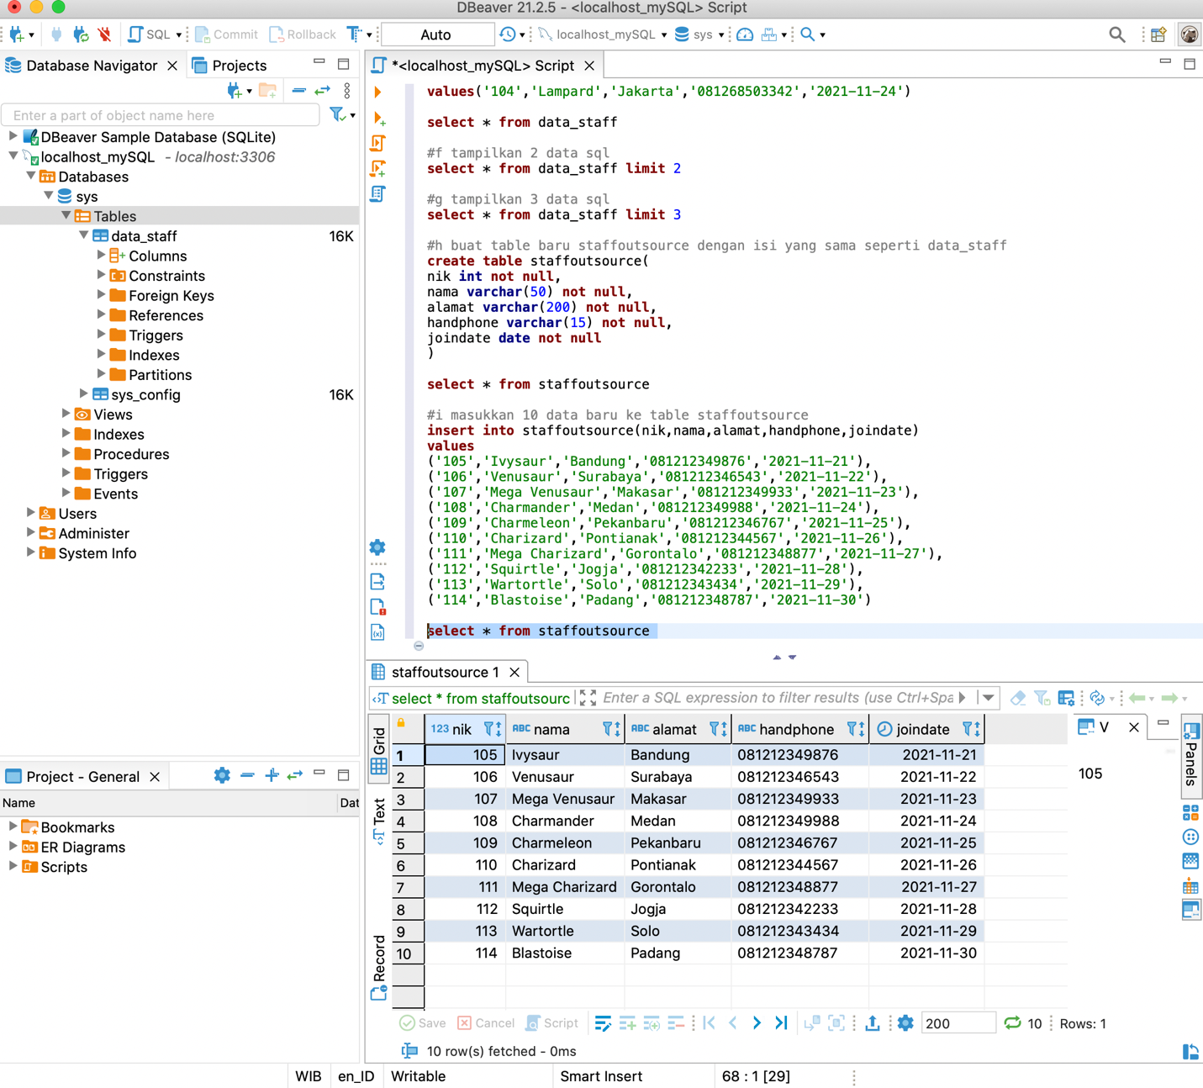**select** * **from** staffoutsource

SOAL J

#j tampilkan data pada 2 table yang sudah kalian buat dengan joindate yang sama

**select** * **from** data_staff **inner** **join** staffoutsource

**on** data_staff.joindate = staffoutsource.joindate

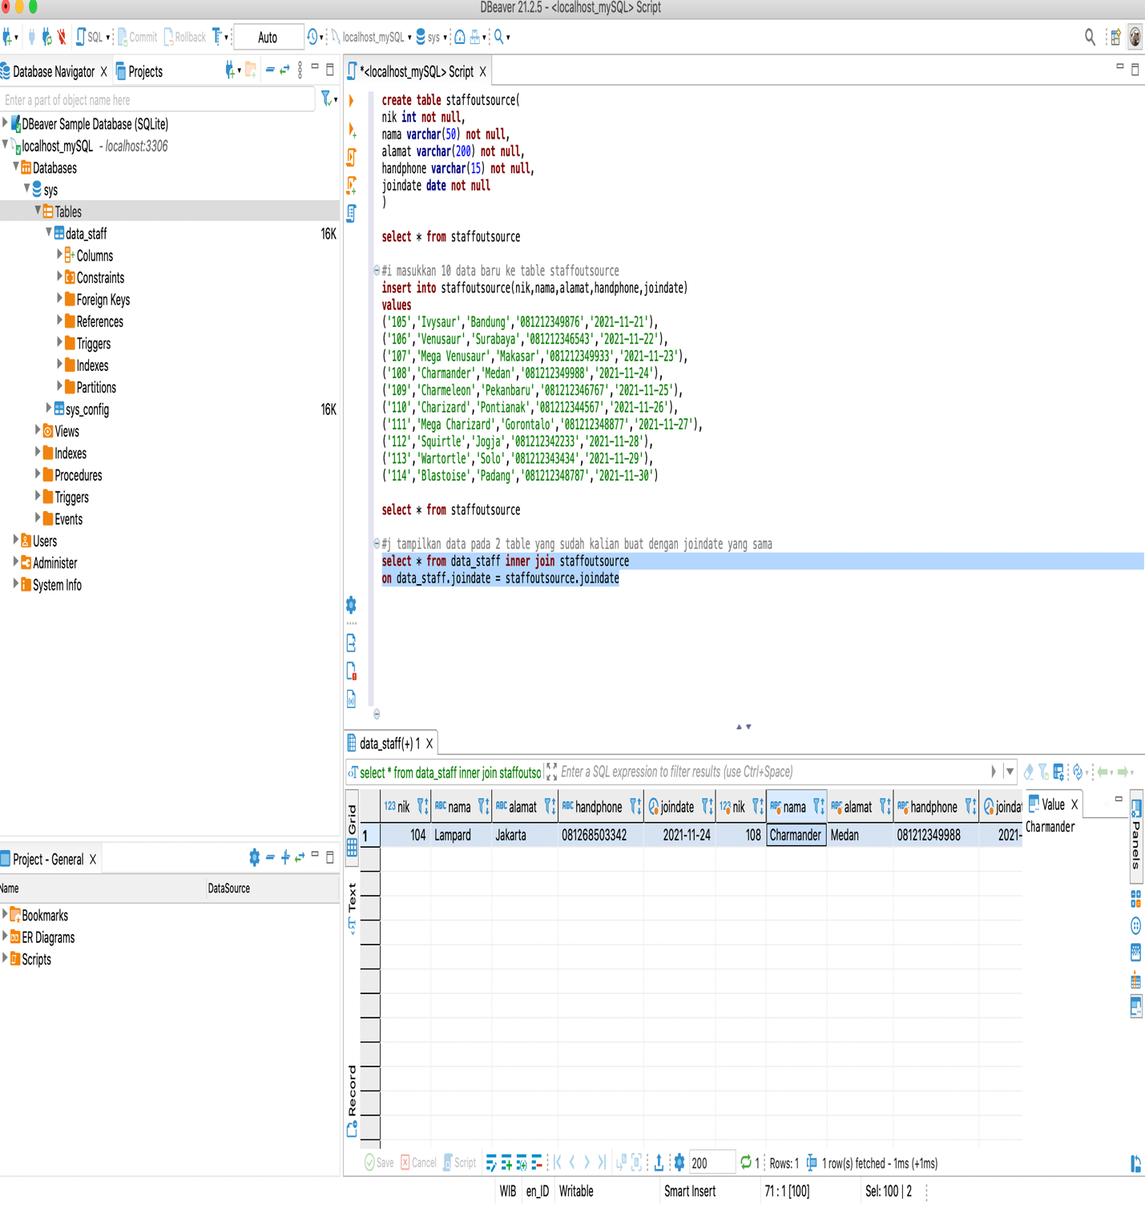

SOAL K

#k tampilkan seluruh data sebelah kanan yang sama pada kedua table

**select** * **from** data_staff **right** **join** staffoutsource

**on** data_staff.joindate = staffoutsource.joindate

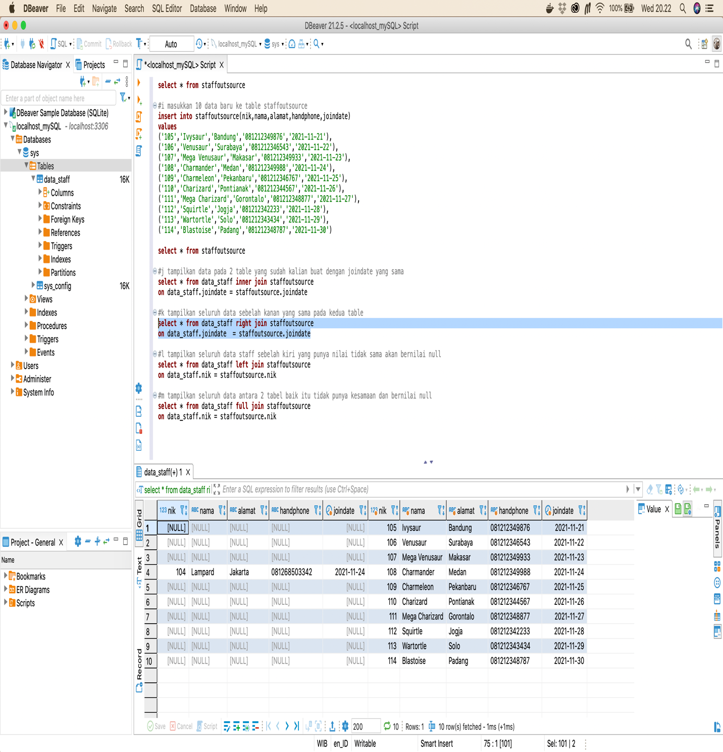

SOAL L

#l tampilkan seluruh data staff sebelah kiri yang punya nilai tidak sama akan bernilai null

**select** * **from** data_staff **left** **join** staffoutsource

**on** data_staff.joindate = staffoutsource.joindate

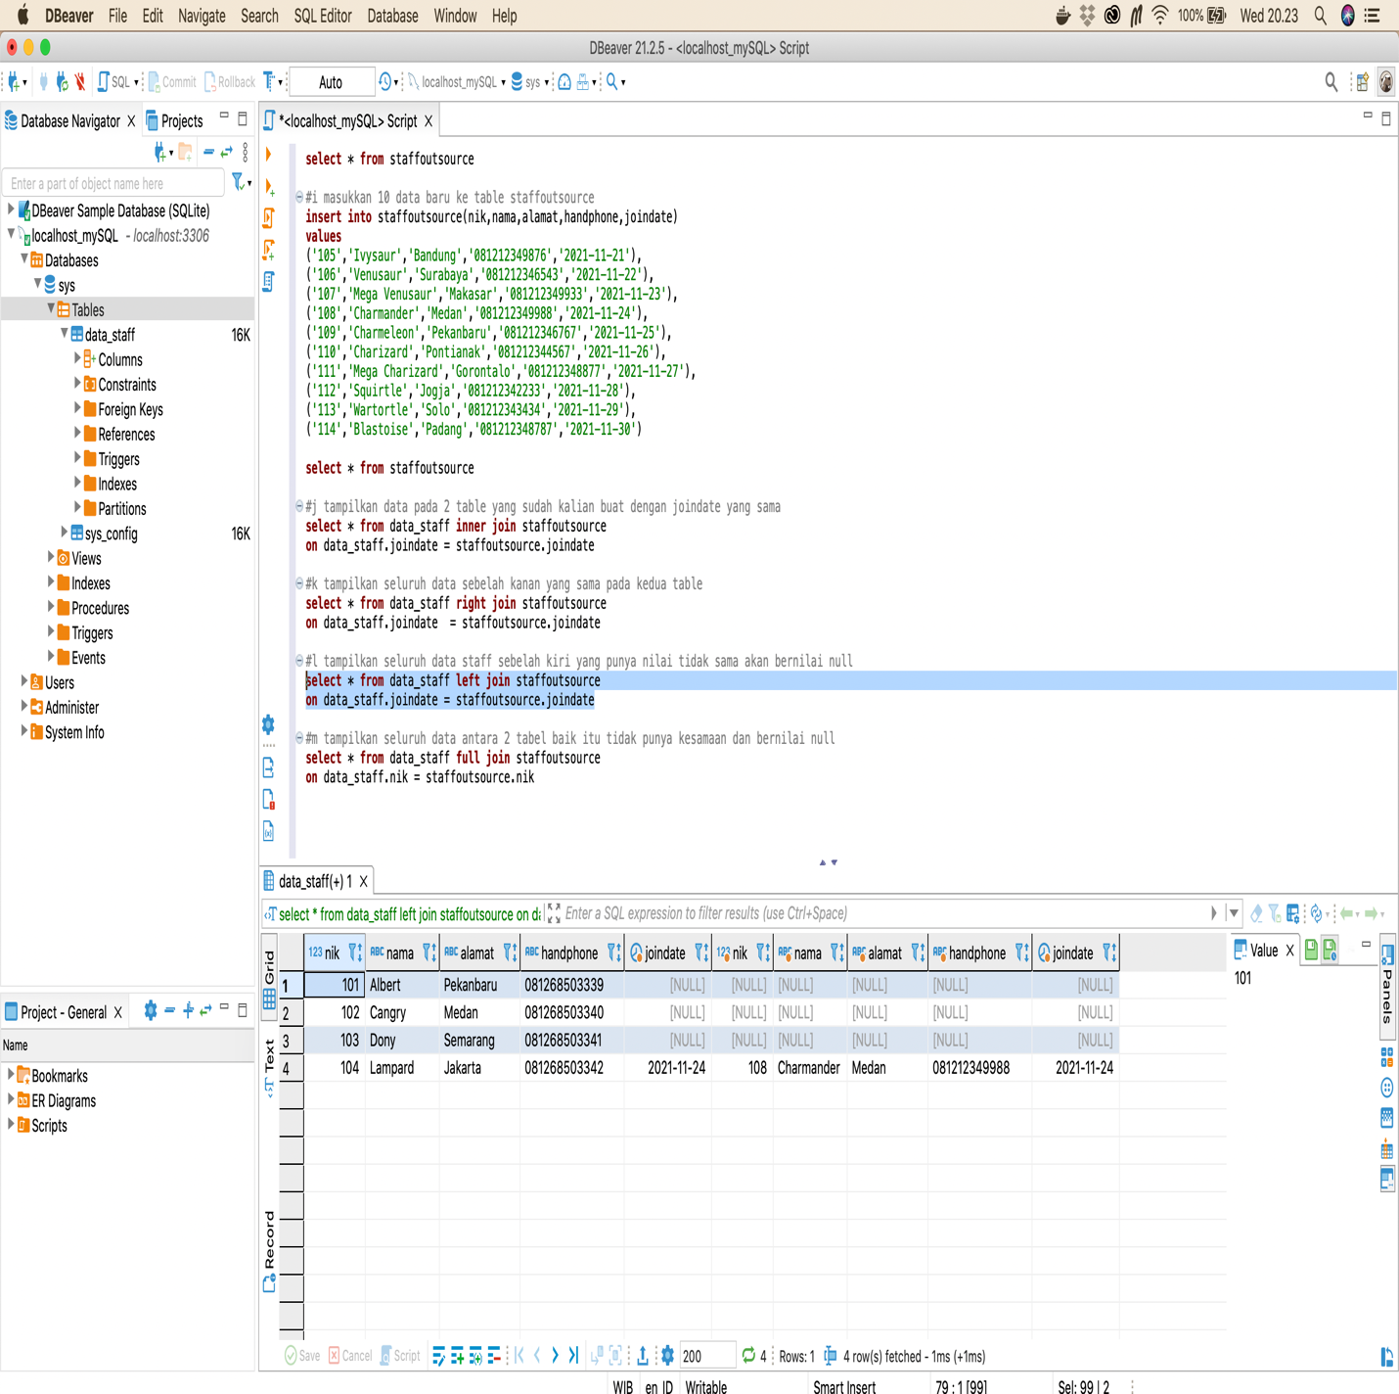

SOAL M

#m tampilkan seluruh data antara 2 tabel baik itu tidak punya kesamaan dan bernilai null

**create** **view** dssos **as** **select** * **from** data_staff **union** **all** **select** * **from** staffoutsource

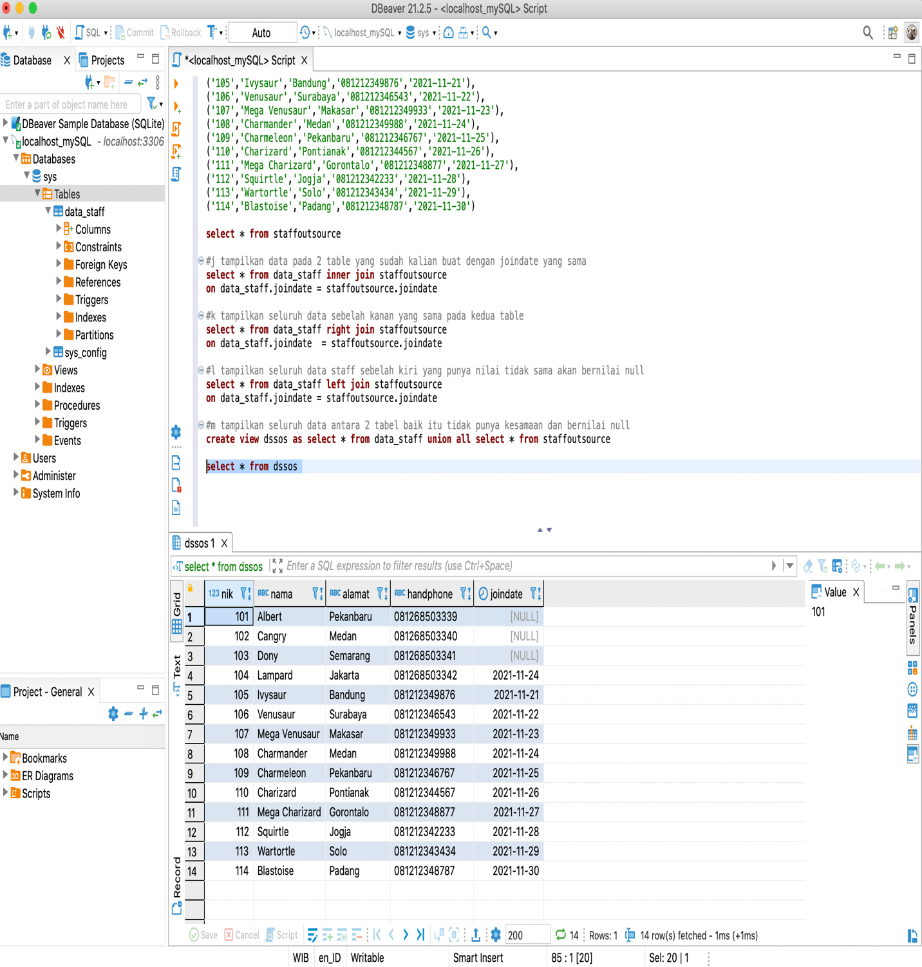**select** * **from** dssos